实验一
#include<iostream>
using namespace std;
class Complex {
double real;
double imag;
public:
Complex(double r = 0.0, double i = 0.0);
void print();
Complex operator+(Complex c);
};
Complex::Complex(double r, double i)
{
real = r; imag = i;
}
Complex Complex::operator+(Complex c)
{
Complex temp;
temp.real = real*c.real-imag*c.imag;
temp.imag = real*c.imag+c.real*imag;
return temp;
}
void Complex::print()
{
cout << "total real=" << real << " " << " total imag=" << imag << endl;
}
int main()
{
double x1, x2, y1, y2;
cin >> x1 >> y1 >> x2 >> y2;
Complex com1(x1, y1), com2(x2, y2), total1;
total1 = com1 + com2;
total1.print();
return 0;
}
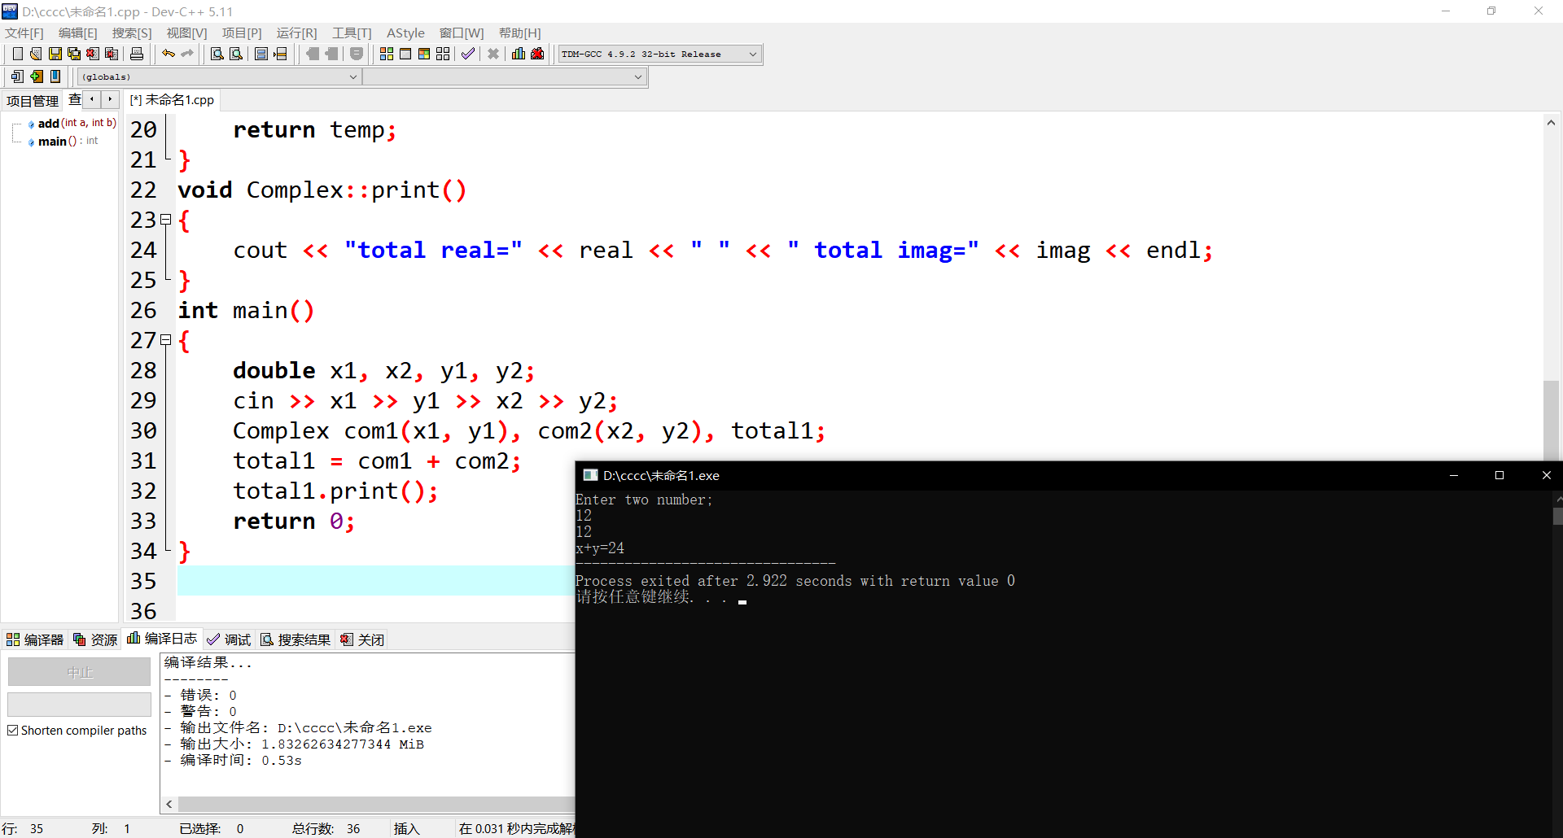

实验二
#include <iostream>
using namespace std;
class complex {
public:
complex() {
real = 0.0;
imag = 0.0;
}
complex(double r_, double i_) {
real = r_;
imag = i_;
}
void print() {
if (imag >= 0)
cout << real << "+" << imag << "i" << endl;
else
cout << real << imag << "i" << endl;
}

complex multiply(const complex& z2) {
complex result;
result.real = real * z2.real - imag * z2.imag;
result.imag = real * z2.imag + imag * z2.real;
return result;
}
private:
// real and imaginary part
double real, imag;
};
int main() {
complex c1(1, 4), c2(3.3, -4.13);
complex c3 ;

c3 = c1.multiply(c2);
c1.print();
c2.print();

cout << "c1*c2=";
c3.print();
return 0;
}
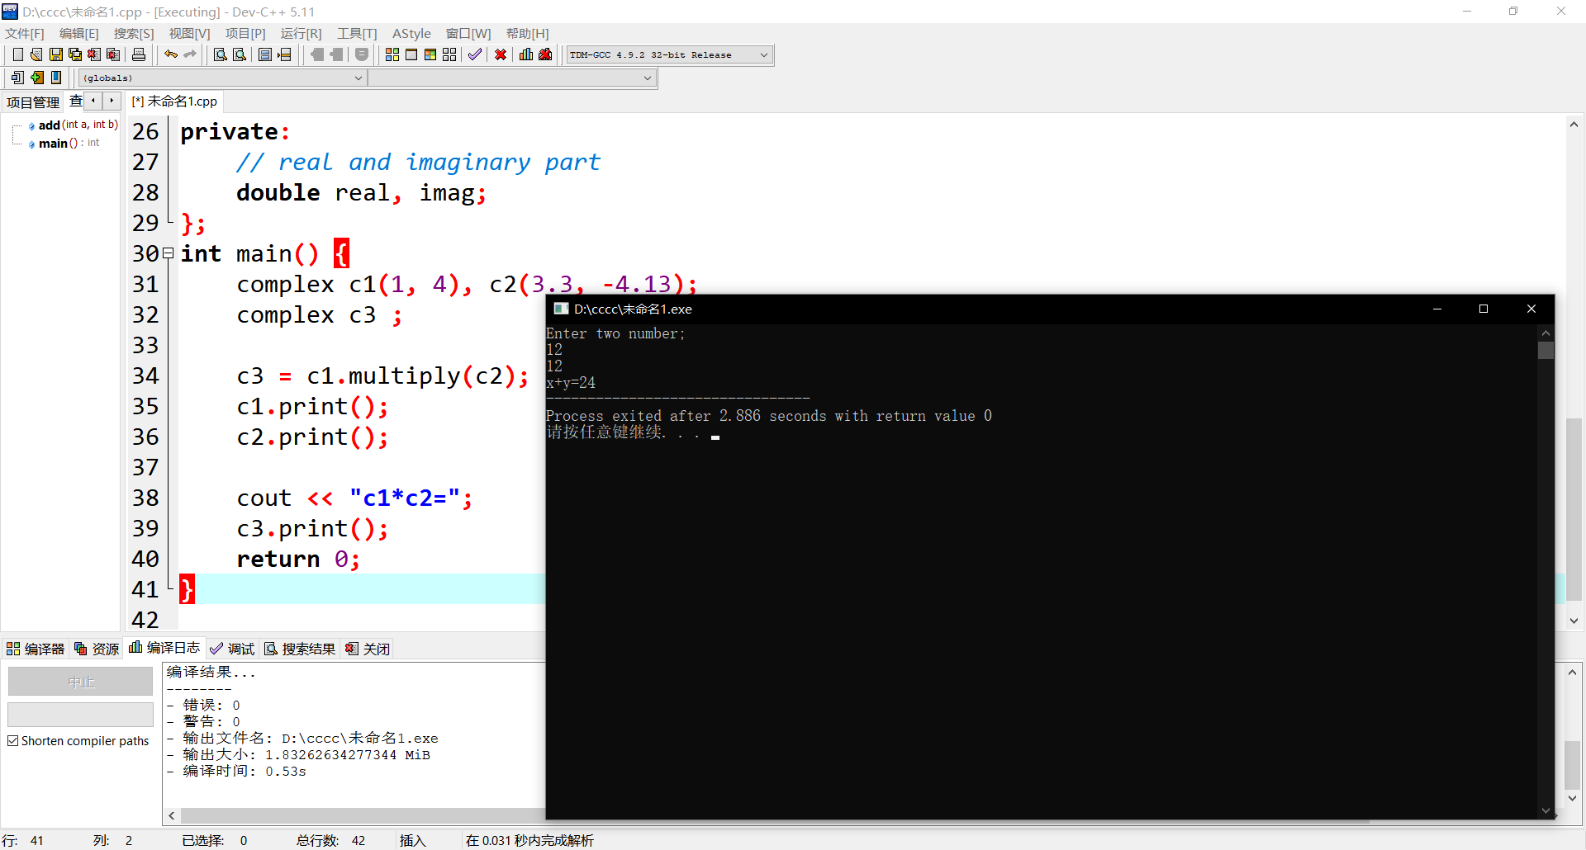
心得体会
这次上机感觉与前两次差不多，已经开始掌握c++的各种符号语言，并且加以应用，我知道这只达到了入门层次，以后也不会有上机了。再下去之后我不会忘了这门课程，好好学习加之巩固。

